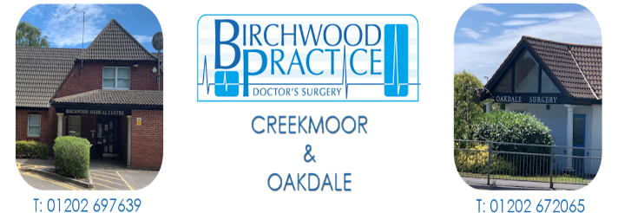

Please join us!

Birchwood Practice is setting up a Patient Participation Group.

What is the Patient Participation Group or PPG?
A Patient Participation Group (PPG) is a group of people who are patients of the surgery and want to help it work as well as it can for patients, doctors, and staff. The NHS requires every practice to have a PPG.

Why should I join?
You have been to the surgery as a patient, parent, carer, or friend.
Your experiences matter and you can bring different ideas to the surgery to help us treat patients better or to improve what we do in some way.
You will also gain a better understanding of the NHS and gather feedback from other patients.



Yes, please, I want to be part of the Patient Participation Group:

Name:
Address:
Telephone:
Email:

Please tick whether you would want to be involved:
⃝ Virtually
⃝ In person

Please tear off this part of the leaflet and hand to the front desk during opening hours.
Monday – Friday 8:30 – 18:30

What is a virtual group?
A virtual group is a group of patients who would like to be part of the Patient Participant Group but prefer not to attend meetings. They get involved online instead. Information such as practice newsletters, minutes of the Patient Participant Group meetings and surveys will be shared electronically. It means that if you can't make it to face-to-face meetings, are caring for someone and unable to leave them, or are working, you can still be kept informed, give your views, and participate.
Will my views be heard?
Your views are important and will be listened to. It may not be possible to act on every suggestion, but all feedback is valuable and will be took into consideration.
Working in a spirit of mutual respect, openness and trust, all patients' views will be discussed ad, where appropriate, we will work together on solutions.

How often does the Participation Group meet?
We will meet at the surgery, but not too often. We know that you are busy, so we meet only a few times per year and hope that you can join us.
If you can't make meeting in person, then don’t worry – you can still be part of our virtual group.
_________________________________
Listening to Patients, Speaking up for Change.

