 | Reasonable Adjustment Consent Form
 | I have read and I understand about having my needs written on the health computer.
 | Yes – ☐ I would like a reasonable adjustment flag  or  No – ☐ I do not want a reasonable adjustment flag
 | Name
 | Date of birth
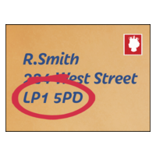 | Post code
 | NHS number if known
 | Signed
 | Date

 | Reasonable Adjustment Consent Form for someone that lacks capacity
 | Best Interest  Having shared this information and made efforts to support the person to understand, you have determined that the person does not have the capacity to decide then a Best Interest Decision can be made to create a Reasonable Adjustment Flag for them. This decision can include the views of the people who know them best, as the clinician working with this person you are the decision maker and an MCA 1 form (care notes) must be completed and kept on their record. Please ensure that you fill out their details and sign, provide your details below:  Client name:  Date of birth:  Post code:  NHS Number:  Name of Clinician:  Role:  Signature: Date:  Names of others involved in the Best Interest Decision to create or amend the Reasonable Adjustment Flag:  Name: Role:  Name: Role:  Name: Role:  Name: Role:  Please indicate if any of the following roles apply where applicable  Lasting power of attorney for health and welfare, Deputy,  Parent, Legal Guardian, Independent Advocate

