
Dorset Council resource booklet
for Carers and those who look after someone else

Do you regularly support an adult, or care for someone with daily tasks, a loved one or a friend? You may or may not identify yourself as a carer, but the caring you do entitles you to information, advice and support.
It is really important that when you're caring for someone that you look after yourself too.
This is particularly important at the moment when some people are increasing the amount of unpaid care they provide.
Caring can be very rewarding, but without the right support it can have a negative impact on your health, career, finances and relationships.
You may have found that your caring role has become more challenging due to the Coronavirus pandemic (Covid-19), or you may have taken on new caring responsibilities. Support is available from a wide range of organisations.
Need help? If you don’t have family, friends or a support network that can help you get the things you need we can help you. Let us know the support you need by completing our online form:
Online: Complete our online form: Start now
Helpline for vulnerable people in need of vital support in the Dorset Council area 01305 221000 8.30am to 5pm, Monday to Friday
Email communityresponse@dorsetcouncil.gov.uk
Information 24/7: Dorset Council website has up to date Covid-19 information:
https://www.dorsetcouncil.gov.uk/emergencies-severe-weather/emergencies/coronavirus/coronavirus-covid-19.aspx
and Adult Social Care information for Carers on Our Dorset adultsocialcare.dorsetcouncil.gov.uk
Printable posters - We have created the following self-isolation posters for you to print and display in your window/front door if you are self-isolating. For safety, we advise using these resources and not the red, amber, green posters being shared online or similar posters that suggests only one person/someone vulnerable lives in the property.
Coronavirus - Self-isolation poster
Coronavirus - Weak immune system poster
Staying safe if someone else is doing your shopping - poster

Alternatively, contact our Customer Services Team on 01305 221016, 8.30am to 5.00pm, Monday to Friday.


Carer Support Dorset is the lead carer organisation for Dorset and the first point of contact for gives advice and support to all age, unpaid carers across the Dorset Council area. Carer Support Dorset’s aim is to create carer friendly communities where carers are recognised, valued and supported. Please read the Carer Support Dorset information leaflet for more information or view their website www.carersupportdorset.co.uk using this link Carer Support Dorset website
Carer Support Dorset is a central point of contact, whether by phone 0800 368 8349 or email admin@carersupportdorset.co.uk, or through the website www.carersupportdorset.co.uk. They will be able to signpost or refer onto a wide range of existing support available for carers. This could include issuing a carers discount card, local carers’ cafes, funding streams and referring to funded services from the local authority through a Care Act carers assessment.
Carer Support Dorset explain in this short video how they can help you with free advice and information. They also provide:
- Welfare calls
- Referrals to Adult Social Care for a Carers Assessment or Care Act Assessment to take place
- Information, advice and guidance
- Virtual cuppas (some with guest speakers)
- Carers sessions on subjects such as manual handling, yoga laughing workshop, dementia
- Quarterly newsletters electronic and hard copy
- ‘Here to talk’ befriending service
- Social media Twitter and Facebook page
- Registration of Carers Cards
- Young carers lead officer – liaising with schools and colleges to reach young carers

Carer Support Dorset can signpost you to a number of local community groups and National support networks which will be able to help you as a carer and support you. Alternatively, you can use the table below to identify areas you may wish to explore yourself.

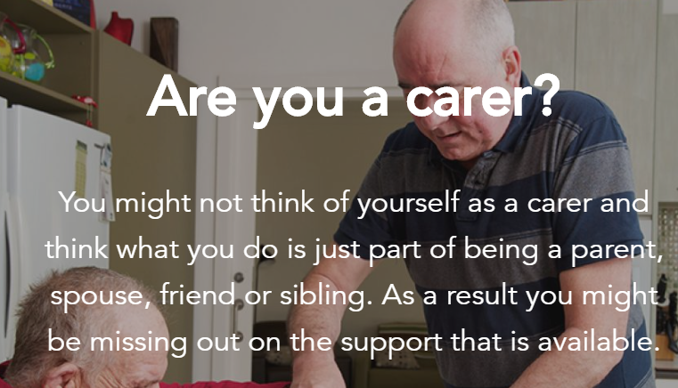

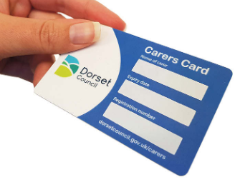



Rethink is the lead organisation working with Carers of people with mental health needs.

- The service supports individual carers by providing practical and emotional support, information, advice and assistance to them in relation to their role as carers and within context of mental health diagnostic and treatment pathways.
- The service supports individual carers to identify their own outcomes and supports carers to achieve these outcomes through a combination of services.
- The service provides 1: 1 support to those carers with an identified need for 1: 1 support or who have high levels of assessed need, as detailed in their Carers' Assessment. The support may be at mental health or universal services across the localities/ Primary Care Network areas or in carers' own homes, subject to completion of appropriate risk assessments by the Provider.
- The service makes use of opportunities to work in partnership with other professionals and agencies wherever possible, and as such has formed working relationships with a wide range of stakeholders in a complex environment.
- The service provider is expected to be pro-active in reaching out to mental health teams and services to fulfil the service aims.

Juniper Lodge, The Conifers, Poundbury Industrial Estate, Dorchester, Dorset, DT1 2PG.
Rethink are available Monday – Friday 9.00am – 4.30pm via mobiles:
Lewis, Service Manager 07483332523
Olivia, Mental Health Recovery Worker 07483939486
Pam, Mental Health Recovery Worker 07866251265
Ren, Mental Health Recovery Worker 07436816039.
National website: https://www.rethink.org/
Local website: https://www.rethink.org/help-in-your-area/services/carer-support/dorset-carers-support/


Support index

Information, advice and support for carers | - Carer Support Dorset  https://www.carersupportdorset.co.uk/  T: 0800 368 8349  - CRISP Carers’ Resource Information and Support for Bournemouth, Poole and Christchurch residents 01202 458204 or Contact BCP Council by calling 0300 123 7052. Find more details here.  - Our Dorset Adult Social Care website https://adultsocialcare.dorsetcouncil.gov.uk/  01305 221016 Mon – Fri 8.30am – 5.00pm  - Help and Kindness community site  https://www.helpandkindness.co.uk/  T: 01305 265893  - Carers Case Worker, Dorset Council  01305 221016 Mon – Fri 8.30am – 5.00pm  - Carers UK  https://www.carersuk.org/home  T: 0808 808 777 Mon – Fri 9am – 6pm. Email: advice@carersuk.org  - Leonardo Trust  http://www.leonardotrust.org  T: 01202 698325  - Dorset Carers Hub, Dorchester, Dorset  www.dorsetcarershub.com  - Help and Care  https://www.helpandcare.org.uk/  T: 0300 111 3303  - Dorset HealthCare NHS University Trust information for Carers  - PramaLIFE https://www.pramalife.org/support-for-carers. Carers support groups (https://www.pramalife.org/pramalife-groups), Carers befriending and mentoring service 07939 001274, respite and sitting service 01202 207300 or Friendship line 01202 022987.  - Age UK North, South and West Dorset can also help with accessing community support as well as helping get essentials such as food and medicine. Call 01305 269444 or email enquiries@ageuknswd.org.uk  - Citizens Advice 0344 411 444 or Visit their national website or find your local Citizens Advice.  - Rethink Dorset Carers Support for people who look after someone living with mental illness. Juniper Lodge, The Conifers, Poundbury Industrial Estate, Dorchester, Dorset, DT1 2PG Monday – Friday 9.00am – 4.30pm. 07483332523, 07483939486. 07866251265, 07436816039.  - Tricuro - support guidance, advice, signposting and carers groups https://www.tricuro.co.uk/  - Department of Work and Pensions / Carers Allowance 0345 608 4321 and Attendance Allowance 0345 6056055  - Silver Line is a free confidential helpline providing information, friendship and advice to older people, open 24 hours a day, every day of the year. 0800 470 80 90  - Samaritans whatever you’re going through, you can call any time from any phone for free 116 123 or email jo@samaritans.org
Hospital information – advice for people going into or leaving hospital | - Triangle of care leaflet by Dorset HealthCare NHS University Trust  - Home First information Dorset HealthCare NHS University Trust https://www.dchft.nhs.uk/patients/Pages/Home-First.aspx  - Visiting hospitals advice: https://www.dorsethealthcare.nhs.uk/coronavirus-1/hospitalinpatient-visitors  - Dorset County Hospital website information https://www.dchft.nhs.uk/Pages/home1.aspx or 01305 251150  - University Hospitals Dorset (Royal Bournemouth Hospital 01202 303626, Poole Hospital 01202 665511 and Christchurch Hospital 01202 486361).  - Resource page for carers about hospitals. https://www.carersupportdorset.co.uk/resource-centre/hospitals-working-with-carers/
Emergency or crisis advice | Medical assistance - please continue to contact your GP. For urgent medical help, use the NHS 111 online service or call 111.  For life-threatening emergencies, call 999 for an ambulance. If you’re advised to go to hospital, it’s important to go.  - Police 999 or non-emergency telephone 101  - Report a concern about an adult to Adult Social Care and Safeguarding. If you have a concern about an adult being abused or neglected call 01305 221016 during office hours. Call 01305 858250 for the Out of Hours Service if it is outside of normal office hours. The out of hours telephone lines are open from 5pm to 8am Monday to Thursday and from 4pm Friday to 8am Monday. Tel: 01305 858250. The Adult Social Care out of hours service provides emergency cover and access to essential services when our daytime services are closed and gives information, advice and, where necessary, makes visits to further assess needs and provide services.  - If you are finding it difficult to manage your personal care, or the care of a family member call our Adult Social Care team on 01305 221016 or email adultaccess@dorsetcouncil.gov.uk.  - Connection 24/7 mental health helpline 0300 123 5440
Coronavirus (Covid-19) information | - If you have any symptoms please self-isolate and call 119 or visit nhs.uk/coronavirus for a test. The primary symptoms of COVID-19 are:  - high temperature (37.8 degrees or more)  - loss of taste or smell  - new continuous cough  - To read about symptoms visit https://www.dorsethealthcare.nhs.uk/coronavirus-1  - Coronavirus information for Carers https://www.dorsethealthcare.nhs.uk/coronavirus-1  - If you have received an NHS letter or are caring for someone who has, you can register for further support here www.gov.uk/cornonavirus-extremely-vulnerable or call 0800 028 8327, the government’s new dedicated helpline.  Dorset Health Care advice for carers  Create an emergency plan  We would advise all carers to create an emergency plan – for you and all those you look after. Having a plan in place can help ease your worries if you are not able to care for those you look after at any point in the future.  In order to create an emergency plan that fits your needs, you will need to consider:  Think about whether there are alternative ways of getting shopping to the person/people you care for –speak to neighbours, family or friends.  We would advise you to access medical assistance remotely, wherever possible. However, if you have a scheduled hospital or other medical appointment during this period, talk to your GP or clinician to ensure you continue to receive the care you need and consider whether appointments can be postponed.  Families may want to think about spending time together in a different way – you may find it valuable to explore Facetime or Skype, for example, as a way to talk face-to-face at a distance. If online communication isn't possible, never underestimate the value of a regular phone call to offer social contact and support.  Make sure your GP or medical professional knows that you are a carer  Please be aware that most GPs are now offering only telephone appointments.  Some GPs may be able to arrange for repeat prescriptions to be delivered to you or your local pharmacy.  If you receive support from health and social care organisations, have care provided for you through the local council or health care system, this will continue as normal. Your care provider will be asked to take additional precautions to make sure you are protected.  Find time for yourself no matter how small  Here are some ideas of things to help you with your wellbeing:  - get out into the fresh air each day  - call friends or family  - learn something new  - ask for help if you need it (remember, this does not mean you cannot manage).  Click here for further advice.  Carer’s assessment  Carers are entitled to a carer’s assessment under the Carer Act 2014. This is an assessment to look at what support you might need to help continue in your caring role at this time. And if you've already been assessed, it is always worth double checking you are receiving everything you're entitled to. Please be aware that, due to COVID-19, all carers assessments are currently being undertaken via a telephone call –or you can complete one online. Find out more about assessments here.  - - COVID-19 helpline leaflet  - - COVID-19 and Emergency Local Assistance(ELA)  - - Dorset energy advice during COVID-19  - - your finances during COVID-19  - - looking after your physical and mental health  - - managing stress and worry  - - young carers groups  - - free COVID-19 masks for carers.  Further useful information:  - carersuk.org/coronavirus includes some answers to some frequently asked questions from carers.  - Government advice (GOV.UK) https://www.gov.uk/coronavirus  - Post code checker find out the local COVID alert https://www.gov.uk/find-coronavirus-local-restrictions  - Dorset Council Coronavirus information https://www.dorsetcouncil.gov.uk/emergencies-severe-weather/emergencies/coronavirus/coronavirus-covid-19.aspx  - Face coverings and mask advice GOV.UK  - NHS Test and Trace - See the GOV.UK website for an overview of the NHS Test and Trace service, including how it works and what happens if you, or someone you have been in close contact with, tests positive for coronavirus (COVID-19).  - Find out about the NHS Test and Trace support payment for employed or self-employed people who have been told to self-isolate.  - If you have been told to self-isolate and are on low income or benefits you may be entitled to the Government's NHS Test and Trace support payment. Apply for a £500 one off self-isolation payment.
Take a break, respite from caring | - PramaLIFE offers a respite and sitting service T: 01202 207300  - Tricuro – reablement (short term and intensive service for up to a maximum of 6 weeks), Night care (provides a responsive and flexible night care service for a maximum of 6 weeks to adults in Bournemouth) or Homecare Services tailored for each person’s needs and can be long or short term. https://www.tricuro.co.uk/  - Tricuro Care Home Short Term Respite for older people or care at home. https://www.tricuro.co.uk/services/support-for-carers/care-at-home/ One of our carers can step in to care for clients whilst their regular carer takes a break for a few hours of for a holiday. T: 0300 330 1202 or email enquiries@tricuro.co.uk.  - Tricuro - Day Services: Connect Services aim to keep people active, healthy and connected to their local communities for as long as possible. They are designed for adults of all ages where they can receive support to take part in activities, learn new skills and meet new friends. Support is also available for personal care, eating and drinking to meet individual needs. Plus Services is specialist services for people with learning disabilities or dementia or people who have support needs relating to their mental health. Provides access to meaningful activities they are not generally able to access in the community. Support is also available for personal care, eating and drinking to meet individual needs.
Befriending, friendship service and support groups | - Age UK wellbeing Telephone friendship service. Age UK and our partner charity The Silver Line offer free telephone friendship services so you can enjoy chatting with someone over the phone, all from the comfort of your own home. Whether you’d like to speak to someone every week, or just want to talk when the need strikes, we’re here to help. T: 0800 4 70 80 90  - Age UK Face to face befriending services are available at many local Age UKs. They will often involve a volunteer befriender visiting an older person in their home, perhaps for a cup of tea and a chat, or accompanying them to an activity (such as a trip to a cafe or the theatre). In some cases, a volunteer may accompany the older person to occasional hospital or doctor's appointments. If you are feeling lonely and would like support T: 0800 678 1602.  - PramaLIFE support group, a club to know what’s going on in your local area.  - Help with meeting new people – we can put you in touch with the befriending groups available complete our on-line form or call the local helpline on 01305 221000.  - You can register with the Volunteer Centre Dorset to become a befriender and chat to others, or you can chat to someone because you’re feeling lonely. Call 01305 229214 or email info@volunteeringdorset.org.uk to register for either service.  - Carer Support Dorset offer a Here to Talk befriending scheme, connecting carers up with friendly volunteers for regular, informal chats over the telephone 0800 368 8349.
Exercise, healthy living, health and mental health | Steps 2 Wellbeing This is suitable for conditions such as depression, low mood, anxiety, obsessive compulsive disorder, post-traumatic stress disorder, phobias, stress and panic disorders. It is available throughout Dorset and provided over the telephone, face to face, in groups, or over the internet. There is an initial screening telephone assessment to identify the type of support that would be suitable. Input is provided by Psychological Wellbeing Practitioners, Counsellors or Cognitive Behavioural Therapists. They accept self-referrals, or referrals from GP’s and other health professionals. See the website www.steps2wellbeing.co.uk for contact details or contact your local Steps team:  Bournemouth and Christchurch  Telephone: 0300 790 0542  Email: dhc.bc.s2w@nhs.net  Poole Purbeck & East Dorset  Telephone: 0300 123 1120  Email: dhc.pped.s2w@nhs.net  West Dorset  Telephone: 0300 790 6828  Email: dhc.west.admin.s2w@nhs.net  - LiveWell Dorset https://www.livewelldorset.co.uk/ 0800 840 1628 / 01305 233 105 Monday to Friday 9.00am – 6.30pm  - Rethink, mental health support https://www.rethink.org/  - Health app, Orcha https://ourdorset.orcha.co.uk/ ORCHA's AppFinder gives you unlimited access to thousands of independent app reviews across all health conditions  - NHS Every Mind Matters Feeling anxious? Simple breathing exercises could help - search Every Mind Matters ttps://www.nhs.uk/oneyou/every-mind-matters/anxiety/  - A mental health guide to coping with lockdown in the winter https://twitter.com/BelievePHQ/status/1320456120004190208?s=20  - Recovery Education Centre (REC) courses The REC offer courses to help people understand their experience and see how they can manage their recovery. Courses take place in community settings throughout Dorset and include Mindful Living, Coping in a Crisis, Understanding Depression and Anxiety. They accept self referrals. Contact 01202 584478 or e-mail recovery.educationcentre@dhuft.nhs.uk  - Wessex Cancer Trust People whose lives are affected by cancer, including families and children, can access counselling at the Trusts Cancer Support Centres. The qualified Counsellors can help people to find helpful and meaningful ways to manage the impact of crisis, loss and stress. They accept self referrals. Contact 01202 315824 or e-mail bournemouth.centre@wessexcancer.org.uk  - The Dorset Self-Management Service supports people living with health conditions and carers. It aims to help people to identify issues affecting their day to day lives and work towards resolutions or just to have more “good days”. The service is coordinated by Help & Care and is NHS funded. There is personal health coaching, advice and practical support to access groups, activities and services. All of this support is available via phone, video or face to face if situation permits. They accept self-referrals online at www.helpandcare.org.uk/selfmanagement or by calling 0303 303 0153.  - Time to Talk Carers counselling available via Carer Support Dorset or Crisp.  - The Leonardo Trust free counselling service for carers. Referral must be made via an intermediary e.g. Carer Support Dorset.  - Tricuro Dementia Care https://www.tricuro.co.uk/services/care-at-home/homecare-services/ 0300 330 1202.
Food shopping and collecting prescriptions | Supermarket referral scheme for Non Shielding Vulnerable People. Are you self isolating due to exposure to COVID-19, potential exposure to COVID-19 or if you have a pre-existing health condition? Help is still available to secure preferential supermarket online delivery slots. Dorset Council have been allocated approximately 1,000 priority slots with Tesco and 1,000 priority slots with Iceland.  To be able to access the slots you must:  - have access to the internet and able to order food online/ or have someone who is able to do this on your behalf  - have the financial means to pay for your food order  - - not have family, friends or a support network that can help you to get shopping in another way  To access the scheme, you can call our helpline on 01305 221000 (8.30am to 5pm Monday-Friday) or email communityresponse@dorsetcouncil.gov.uk complete the Covid Online Form  Access to food - You should talk to family, friends or your support network to see if they can help you get food and medicine. We have been working closely with local support groups and charities to help provide communities with the best support possible. If you would like to find out more about the types of community support available, you can search for your local area on the Help and Kindness website.  Help with collecting medicine, complete our on-line form call the local helpline on 01305 221000.  Foodbanks - You can contact your local foodbank for guidance on required items and how to drop off or collect items. Find details of your local foodbank or search https://www.helpandkindness.co.uk/search/Dorset/foodbank  - Food delivery services  https://www.helpandkindness.co.uk/search/Dorset/shopping+assistance  - Community fridges  https://www.helpandkindness.co.uk/search/dorset/community+fridge  - Hot meals  https://www.helpandkindness.co.uk/search/dorset/hot+meals  - Food parcels  https://www.helpandkindness.co.uk/search/dorset/food+parcels  - Free prescription delivery services  - https://www.nhs.uk/apps-library/echo/  - https://www.pharmacy2u.co.uk/prescriptions/electronic-prescription-service-nhs-ppc?gclid=EAIaIQobChMI9K_XvvPc7AIVl-3tCh2Q-wasEAAYASAAEgLbavD_BwE&gclsrc=aw.ds  - https://www.boots.com/online/pharmacy/  Search the internet for more services near you.  - Free prescription collection service to your door  https://www.helpandkindness.co.uk/search/dorset/prescription+collection  - Staying safe – if someone else is doing your shopping do ask for help – work with trusted organisations and volunteers make arrangements for help over the phone with a trusted organisation, not with a stranger on the doorstep. Don’t hand money over without having your shopping and a receipt. Have your food left on the doorstep, do not let the person in your home. Put money in an envelope and give to the volunteer at a distance. Ensure you keep a 2 metre distance from the person delivering your shopping. Wash your hands (for 20 seconds) and surfaces after unpacking the shopping.  - Carer Support Dorset have a poster for carers to show that they are unpaid carers and are allowed to access supermarkets during allocated carers hours. Contact them for more information: 0800 368 8349
Activities, entertainment and social for wellbeing | - Become a Befriender: You can register with the Volunteer Centre Dorset to become a befriender and chat to others, or you can chat to someone because you’re feeling lonely. Call 01305 229214 or email info@volunteeringdorset.org.uk to register for either service.  - Virtual Cuppa with Carer Support Dorset or telephone 0800 368 8349  - Befriending friendship groups – would you like to host or participate in them? Contact PramaLIFE 01202 804914 or email keith.grubbins@pramalife.org  - Befriending: Carer Support Dorset ‘Here to Talk Service’ 0800 368 8349.  - Prama Memory Lane Group, sharing memories are regular, open, friendly activities available to support people with dementia or memory loss as well as supporting their carers. People do not need to have a diagnosis of dementia to attend any of our groups, in fact some people come along because they are feeling a little lonely. Each session starts with lots of chat around tables in smaller groups and then moves on to whole group activities. Memory lane activities include reminiscence, games, quizzes, music and singing, conversation and the opportunity to get other information, signposting and support from others experiencing the same issues. 01202 804914  - Prama also offer a Craft and Chat or Sporting Memories groups.  - The Memory Box Newsletter by The Wessex Heritage Trust  - Tricuro activities T: 0300 330 1202 or email enquiries@tricuro.co.uk.  - Carer Support Dorset activities - 0800 368 8349 Virtual Cuppas, blog, social media sharing of ideas. (Carers may be eligible for equipment e.g. laptop/tablet via The Leonardo Trust – contact Carer Support Dorset for information).  - Age UK Befriending service: The befriender can ask the vulnerable person if they consent to being referred to the reablement services on offer from the council’s care provider Tricuro. Age UK advice line: 0800 678 1602 s  - Some theatres and cinemas have existing carers schemes for reduced entry, parking etc. Contact them direct for information.
Getting online, technology and equipment | - Equipment ideas to help you in the home Our Dorset Adult Social Care website https://adultsocialcare.dorsetcouncil.gov.uk/  - Care Technology ideas to help you in the home Our Dorset Adult Social Care website https://adultsocialcare.dorsetcouncil.gov.uk/  - Advice regarding equipment to help you in the home: AskSARA, Living made easy https://asksara.livingmadeeasy.org.uk/. Independent Living  https://www.independentliving.co.uk/  Dorset Digital Hotline - free digital support - Do you need help getting online? Dorset Council are now offering IT support over the phone. No problem too small. Ring 01305 221000 between 10am-12pm weekdays except Bank Holidays and we’ll put you through to the most appropriate advisor. See more information about how we can help you get online.  - FREE computer training to help you get online: Christchurch-based charity The Water Lily Project provide free support to anyone struggling with our online world. Based at the charity’s community café in Barrack Road in Christchurch, an IT suite is available to offer one to one training every Wednesday from 10.15am to 1.45pm. Places must be booked in advance to adhere to Covid guidelines and social distancing rules.  Because of Covid restrictions, there will also be free support available over the phone. To book a one-to-one computer training session at The Water Lily Project computer suite or a one to one over the phone call 01202 246763 (answerphone available out of hours) or if you have access to email, contact it@waterlilyproject.org.uk.  - Possible funding of technology e.g. smart phone/laptop via The Leonardo Trust – Carer Support Dorset can put in a funding request referral.
Coping with grief, bereavement and worries | - Samaritans T: 116 123  - CAB – Citizens Advice  - Low mood booster, 9 ways to boost your mood when you are feeling low https://twitter.com/BelievePHQ/status/1295337162653696003?s=20.  - Wellbeing support and local mental health and therapy services are available to help. Please visit the Dorset Healthcare website. You'll find information and advice and helpline numbers to deal with the stress and distress of facing COVID-19. If you are in urgent need of mental health advice and support, Dorset HealthCare's Connection service offers a 24-hour helpline on 0300 123 5440.  - Cruse bereavement https://www.cruse.org.uk/ T: 0808 808 1677 will support you after the death of someone close.  - Carer Support Dorset information pages on their website https://www.carersupportdorset.co.uk/resource-centre/bereavement-and-loss-life-after-caring/  - Tricuro end of life care – providing care and support for people who are in their last few hours or days of their life as well as those with a terminal condition which has become advanced. T: 0300 330 1202 https://www.tricuro.co.uk/services/care-at-home/homecare-services/
Financial support/advice and benefits information | - Test and Trace Support Payment: If you have been told to self-isolate and are on low income or benefits you may be entitled to the Government's NHS Test and Trace support payment. Apply for a £500 one off self-isolation payment.  - Find out about the NHS Test and Trace support payment for employed or self-employed people who have been told to self-isolate.  - Carers UK https://www.carersuk.org/home  T: 0808 808 777 mon – Fri 9am – 6pm  - Age UK North, South and West Dorset can also help with accessing community support as well as helping get essentials such as food and medicine. Call 01305 269444 or email enquiries@ageuknswd.org.uk  - Carer Support Dorset - https://www.carersupportdorset.co.uk/  T: 0800 368 8349  - Council tax advice to include exemptions and discounts. Contact information  Stour Valley and Poole Partnership – East Dorset: 0345 034 4569  Stour Valley and Poole Partnership - North Dorset: 0345 034 4569  Purbeck area: 01929 557357  Weymouth and Portland: 01305 211970  West Dorset area: 01305 211970  - Energy saving advice from Dorset Community Action 01202 847610  - Financial difficulties? If you are struggling financially and need some advice, call Dorset Citizens Advice line on 0800 144 8848, textphone 0800 144 8884 or visit our Reaching Out pages. They can also advise regarding benefits you may be entitled to.  - Heating or energy costs - Call the Citizens Advice Dorset Energy helpline on 01929 775500.  - Post Office cash schemes - The Post Office have made it easier for those self-isolating to access cash products with the following schemes: ‘Payout Now’ - this is a voucher sent by text, email or post to a self-isolating customer who can then share it with a trusted individual to withdraw cash on their behalf ‘Fast PACE’ – this is a service that allows a self-isolating customer to arrange for a trusted individual to collect the cheque from them, cash it at Post Office, and return with the cash. Please see the following websites for further information: My news desk  - BBC news  - The Leonardo Trust hardship grants – can be applied for by contacting Carer Support Dorset - https://www.carersupportdorset.co.uk/  T: 0800 368 8349
Learning something new and skills | - Dorset Volunteer Centre - You can register with the Volunteer Centre Dorset to become a volunteer. Have you considered becoming a Befriender and chat to others, or you can chat to someone because you’re feeling lonely? Call 01305 229214 or email info@volunteeringdorset.org.uk to register for either service.  - Carer Support Dorset learning opportunities – training, volunteering.  - Adult Training courses: 01202 262300 https://www.webenrol.com/SkillsAndLearningbdp/  - Tricuro Work Based Training enables adults with learning disabilities to gain knowledge, skills and confidence, enhancing their opportunities for employment. https://www.tricuro.co.uk/
Legal information | - Power of Attorney advice – Contact an Independent financial advisor or Citizens Advice for information 0344 411 444 or Visit their national website or find your local Citizens Advice.  - Living Will advice – Age UK advice https://www.ageuk.org.uk/information-advice/money-legal/legal-issues/advance-decisions/ or Citizens Advice (CAB) 0344 411 444 or Visit their national website or find your local Citizens Advice.  - Advocacy – Dorset Advocacy’s independent advocates help to ensure that rights are upheld, and that peoples’ views, wishes and needs are heard, respected and acted upon. https://www.dorsetadvocacy.co.uk/ 0300 434 7000. Email: enquiries@dorsetadvocacy.co.uk  - What to do if your cared for has passed away?  Information is available from Carer Support Dorset. - https://www.carersupportdorset.co.uk/ 0800 368 8349.  Carers UK https://www.carersuk.org/help-and-advice/practical-support/when-caring-ends/bereavement 020 7378 4999  Age UK https://www.ageuk.org.uk/information-advice/care/helping-a-loved-one/my-caring-role-has-changed/ 0800 678 1602 8am – 7pm 365 days a year

Useful posters and media
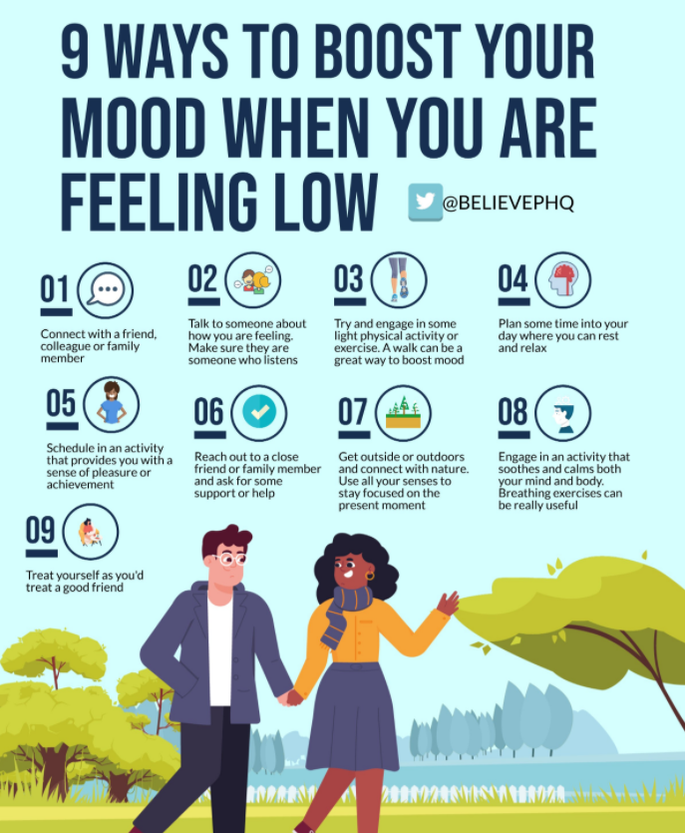
https://twitter.com/BelievePHQ/status/1295337162653696003?s=20
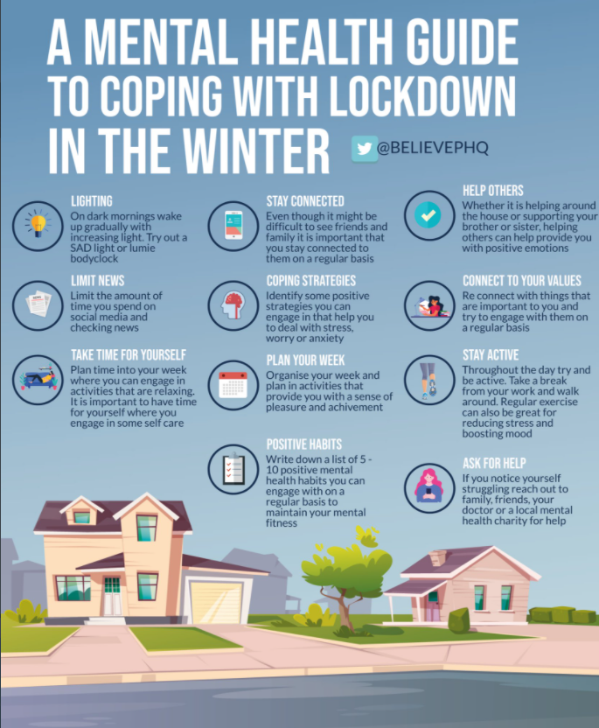
https://twitter.com/BelievePHQ/status/1320456120004190208?s=20

